**Problem 1**

Dimensions

**Franchise**

FranchId: Franchise.FranchId

Franchise.FranchRegion

Franchise.FranchPostalCode

Franchise.FranchModelType

**Product**

ProductId: Merchandise.MerchId | ServiceCategory.ServCatId | Event type code from Worksheet

ProductName: Merchandise.Name | ServiceCategory.ServCatName | Event name from Worksheet

ProductType: derived column indicating type Service or Merchandise or Special Event

**Customer**

CustId: Member.MmbrId | Corporate customer Id from Worksheet

Customer Name: Member.MmbrName | Corporate Customer Name from Worksheet

CustZip: Member.Zip | Default value “0” for corporate type

Customer Location: Franchise.FranchRegion | default 0 for Corporate

Customer Type: derived column hierarchical Private -> Guest or Member | Corporate (not hierarchical)

Member TypeId: MemberType.MemtypeId | Default 0 for guests and corporate

Member Type Name: MemberType.MemberTypeName

**Calendar**

Date columns in the ERD (Sale, ServPutchase, Member, Event Date at worksheet) and spreadsheet (PurchDate); hierarchical (year -> month -> week->day)

Problem 2

**Fact Table**

FactId

Qty: Contains relationship | Default “1” for Service type or Special Event

Price: Contains.Qty*Merchandise.MerchPrice (as it is said in assignment: “For merchandise, sales amount is computed as quantity times selling price”) | ServiceCategory.ServCatPrice| Worksheet.Amount

Problem 3

Grain

Detecting **fact table** size:

Fact table size equals the sum of sold merch, services and special events

Number of merch purchases is taken from Contains table = 450000

Services sales detected by ServPurchase table = 10000

Special events should be taken from Worksheet = 300 per 200 franchises = 60000

Detecting dimensions sizes:

**Franchise** = 350

**Product** is sum of unique products from Merchandise, ServiceCategory, Worksheet = 500+20+150=670

As number of unique Event type codes for Worksheet is not specified I supposing that every unique corporate customer has unique event (150).

**Customer** is sum of unique members and corporate customers = 50000+150=50150

**Calendar** has 365 rows

Sparsity = 1 – (60000/(350*670*50150*365))= 0.999999986022

Problem 4

Email and Customer names are not used because specified business needs don’t indicate its usage.

New derived columns are added to Product (ProductType) and Customer (CustomerType)

Using star schema

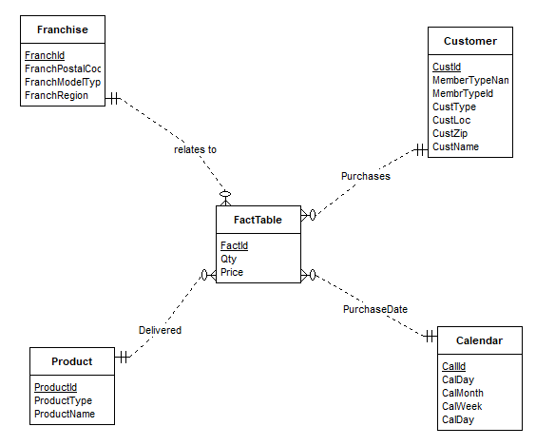

Problem 5

To avoid incomplete fact-dimension relationships several default values are designed:

* CustZip to “0” if customer has not Zip code
* CustLoc to 0 if customer has no location or it is unknown. At worksheet table location is included at customer name and cannot be used separately.
* MemberType to 0 if customer is guest or corporate
* Qty at fact table should be set at 0 for service product type or special event

As it is said in assignment: “For merchandise, sales amount is computed as quantity times selling price”. Therefore we must calculate price for merch using Qty and MerchPrise

Price = Contains.Qty*Merchandise.MerchPrice

Members location is detected by location of related franchise

As management wants to see details by week, to calendar table week attribute is added.

Problem 6

Examples of tables

|  |  |  |  |  |  |  |
| --- | --- | --- | --- | --- | --- | --- |
| Franchise | | | |  |  |  |
| FranchId | FranchRegion | FranchPostalCode | FranchModelType |  |  |  |
| F1 | Northwest | 98011 | Full |  |  |  |
| F2 | Mountain | 80111 | Medium |  |  |  |
| F3 | Central | 45236 | Limited |  |  |  |
|  |  |  |  |  |  |  |
|  |  |  |  |  |  |  |
| Customer | | | | | | |
| CustId | CustName | CustType | MembrTypeId | MemberTypeNme | CustZip | CustLoc |
| 1111 | Joe | Member | M1 | Platinum | 98011 | Northwest |
| 2222 | Mary | Member | M2 | Gold | 80112 | Mountain |
| 3333 | Sue | Member | M3 | Value | 45327 | Central |
| 4444 | George | Guest | 0 | 0 | 45236 | Central |
| CC1 | First Data, Greenwood Village | Corporate | 0 | 0 | 0 | 0 |
| CC2 | DU Tennis, Denver | Corporate | 0 | 0 | 0 | 0 |
| CC3 | Creek High School, Greenwood Village | Corporate | 0 | 0 | 0 | 0 |
|  |  |  |  |  |  |  |
|  |  |  |  |  |  |  |
| Product | | |  |  |  |  |
| ProductId | ProductType | ProductName |  |  |  |  |
| MC1 | Merchendise | Wilson balls |  |  |  |  |
| MC2 | Merchendise | Wilson racket |  |  |  |  |
| MC3 | Merchendise | Adidas shoes |  |  |  |  |
| MC4 | Merchendise | Racket stringing |  |  |  |  |
| SC1 | Service | Ball machine |  |  |  |  |
| SC2 | Service | Private lesson |  |  |  |  |
| SC3 | Service | Adult class |  |  |  |  |
| SC4 | Service | Child class |  |  |  |  |
| L-A | Special | Adult Social |  |  |  |  |
| L-B | Special | Pioneer Social |  |  |  |  |
| L-C | Special | Team Practice |  |  |  |  |
|  |  |  |  |  |  |  |
|  |  |  |  |  |  |  |
| Date | | | | |  |  |
| CalId | CalDay | Week | CalMonth | CalYear |  |  |
| C00010 | 10 | 1 | 2 | 2013 |  |  |
| C00011 | 11 | 1 | 2 | 2013 |  |  |
| C00012 | 12 | 1 | 2 | 2013 |  |  |
| C00013 | 13 | 1 | 2 | 2013 |  |  |
| C00014 | 14 | 1 | 2 | 2013 |  |  |
| C00015 | 15 | 1 | 2 | 2013 |  |  |
| C00016 | 16 | 1 | 2 | 2013 |  |  |
| C00017 | 17 | 2 | 2 | 2013 |  |  |
| C00018 | 18 | 2 | 2 | 2013 |  |  |
| C00019 | 19 | 2 | 2 | 2013 |  |  |
| C00020 | 20 | 2 | 2 | 2013 |  |  |
| C00021 | 21 | 2 | 2 | 2013 |  |  |
|  |  |  |  |  |  |  |
|  |  |  |  |  |  |  |
| FactTable | | | | | | |
| FactId | CalId | ProductId | FranchId | CustId | Qty | Price |
| F001 | C00010 | MC1 | F1 | 1111 | 2 | 6 |
| F002 | C00010 | MC2 | F1 | 1111 | 1 | 200 |
| F003 | C00013 | MC4 | F2 | 2222 | 1 | 40 |
| F004 | C00013 | MC3 | F2 | 2222 | 1 | 100 |
| F005 | C00014 | MC4 | F3 | 3333 | 1 | 40 |
| F006 | C00013 | SC1 | F1 | 1111 | 1 | 15 |
| F007 | C00014 | SC2 | F2 | 2222 | 1 | 75 |
| F008 | C00015 | SC3 | F4 | 4444 | 1 | 150 |
| F009 | C00013 | L-A | 0 | CC1 | 1 | 1000 |
| F010 | C00014 | L-B | 0 | CC2 | 1 | 500 |
| F011 | C00021 | L-C | 0 | CC3 | 1 | 200 |